

Issued on: 15/06/2026 Enroll on: 230020116060

internship completion certificate

This is to certify that Chaitya shah successfully completed internship with grade A for Python With Data Analytics conducted by Vibrant Technology from 15/05/2026 to 15/06/2026 at 801, Silicon Tower, Law Garden, opp. Axis Bank, Ellisbridge, Ahmedabad,.

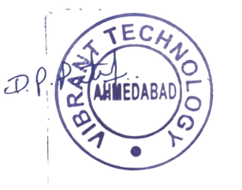
Certified by:

Vibrant Technology Team Leader

info@vibrantwebtech.in

+91 8511110213

801, Silicon Tower, Law Garden, opp. Axis Bank, Ellisbridge, Ahmedabad, Gujarat 380006

